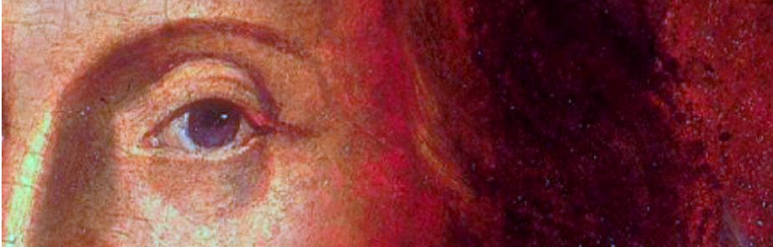
Sidelights on
Shakespeare

Tuesday
9th June2015
4pm

Room 3 Wolfson Research Exchange

Birthday cake and wine to follow.
All staff and students welcome

An Interdisciplinary research seminar
The Incomplete Works of William Shakespeare: Handling the Apocrypha

To celebrate our 5th birthday, we are delighted to welcome back one of the original founders of Sidelights on Shakespeare:

Dr Peter Kirwan
University of Nottingham

Dr Kirwan will open up the key questions surrounding the so-called ‘Shakespeare Apocrypha’ in light of the most current developments in Shakespeare editorial practice. As new major ‘Complete Works’ projects seek to consolidate the constitution of the canon while other multi-volume series add ever more plays, what is at stake in editing and author-ising those plays whose authorship may never be resolved beyond doubt?

@sidelights_on
Visit us on the web: go.warwick.ac.uk/shakespeare
